Logic Model Example: Addressing Food Insecurity for People with Disabilities in Columbus County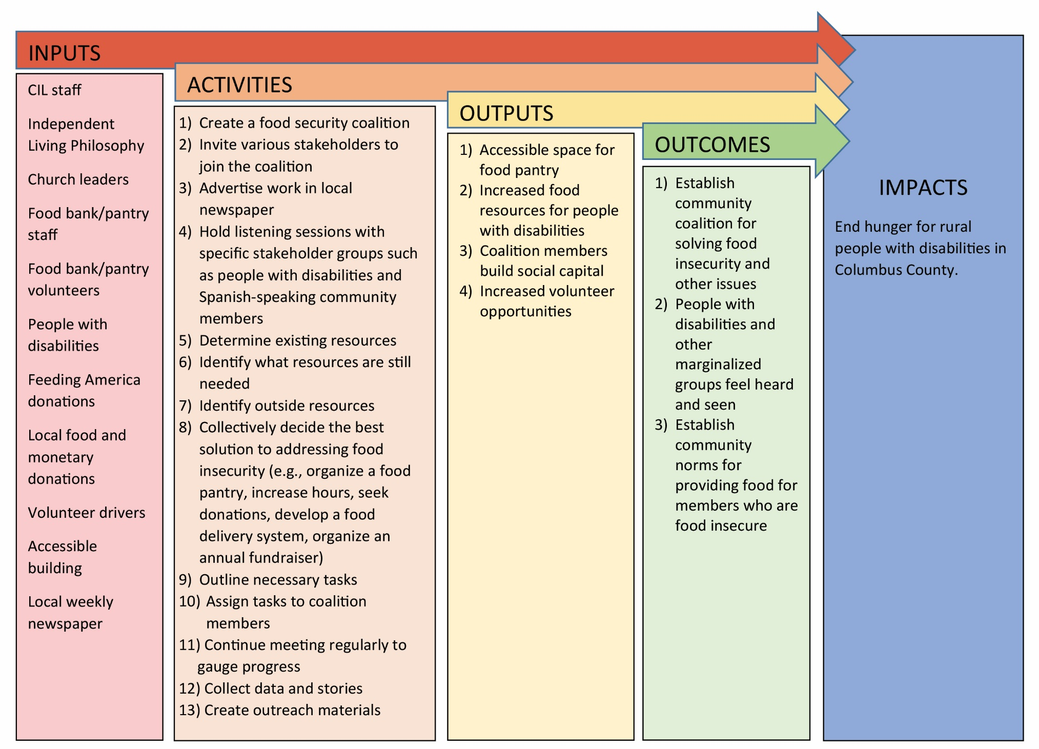
Write Out Your Own Logic Model
Inputs:

Activities:

Outputs:

Outcomes:

Impacts:

Logic Model Template